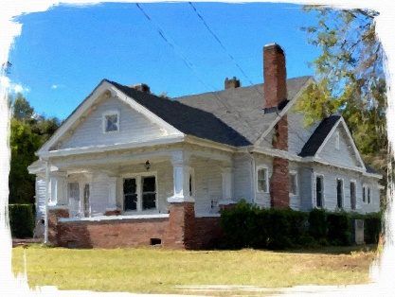  27. A. L. Reaves House | 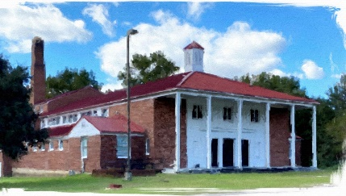  28. Ashwood School Gymnasium & Auditorium | 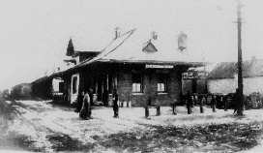  29. Atlantic Coast Line Railroad Depot |  | 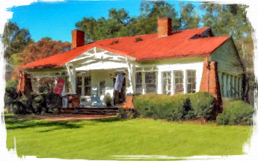  30. Ava Woodham House
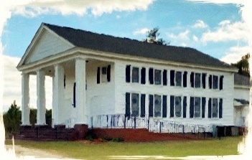  31. Bethany Baptist Church  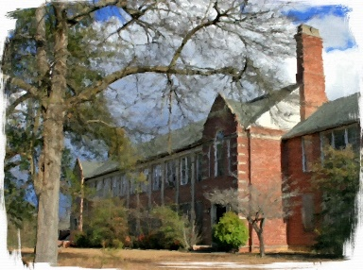  35. Bishopville High School  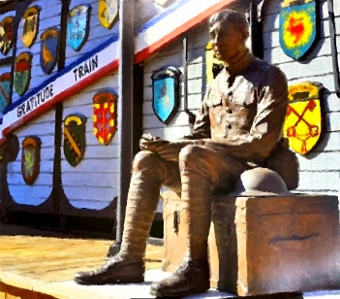  39. Capt., James Davison Heriot, Statue  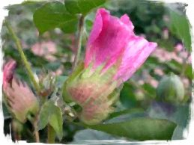  43. Cotton Bloom Pink  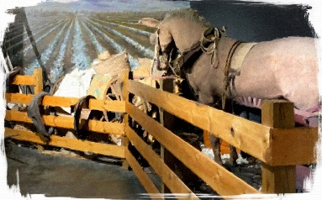  47. Cotton Planting & Harvesting  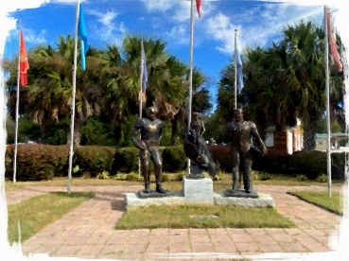  51. Felix “Doc” Blanchard  Flag Park  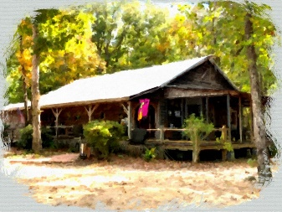  55. Harry and Harry, Too  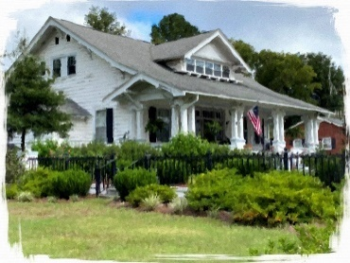  59. L.W. Moore House  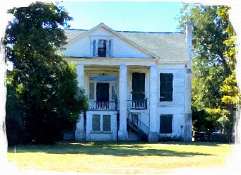  63. Longview  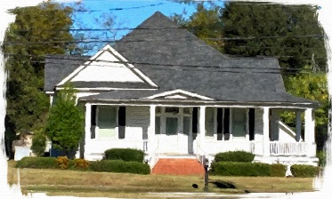  67. Mary Parrott House  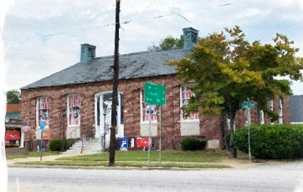  71. Old Post Office  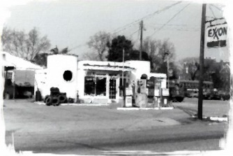  75. Roland Elmore & Sons  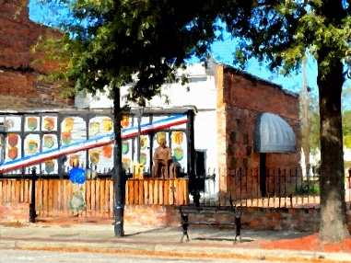  79. South Carolina  Merci’ Train  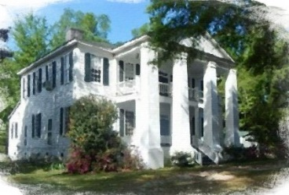  83. Tall Oaks  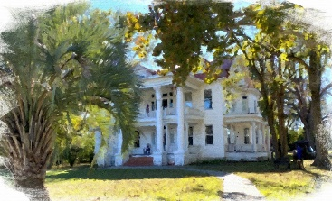  87. The Manse, Mt. Zion  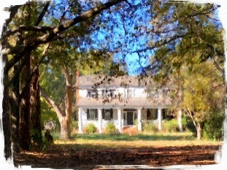  91. Thomas Fraser House  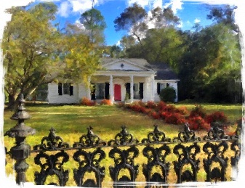  95. Williford House | 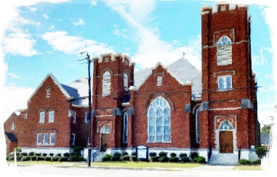  32. Bethlehem United Methodist Church  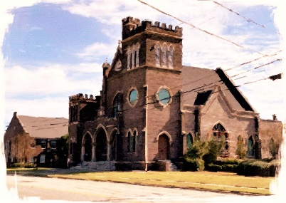  36. Bishopville Presbyterian Church  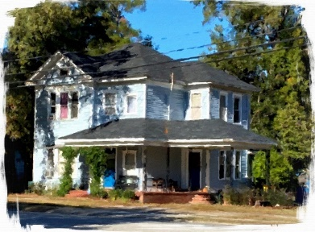  40. Charles Reames House  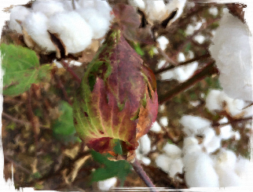  44. Cotton Boll  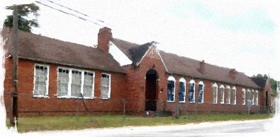  48. Dennis High School  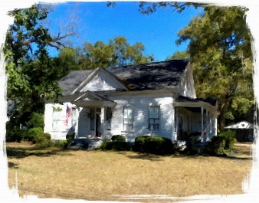  52. Flex “Doc” Blanchard House  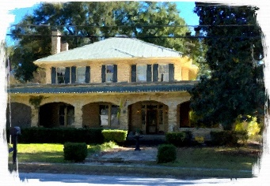  56. J.M. Hearon House  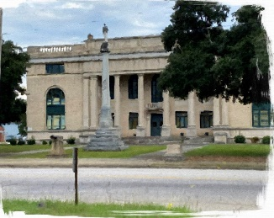  60. Lee County Courthouse  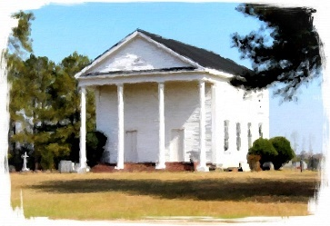  64. Lynchburg Presbyterian Church  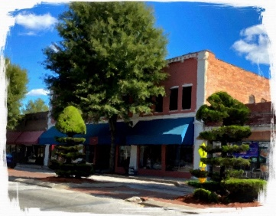  68. McClure Building  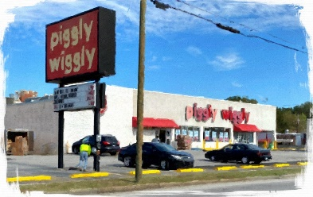  72. Piggly Wiggly  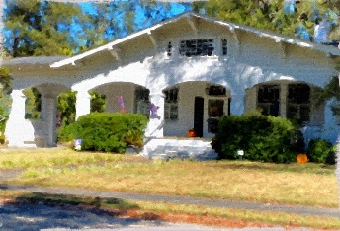  76. Ruffin House  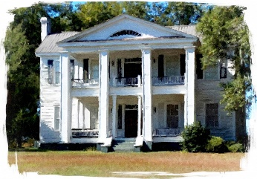  80. Spencer House  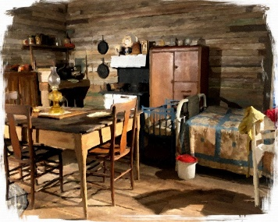  84. Tenant House, Bed & Kitchen  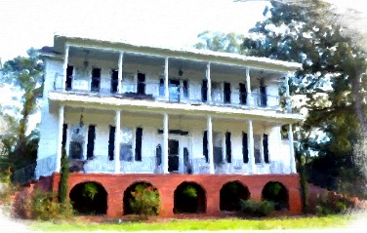  88. The Oaks, St. Charles  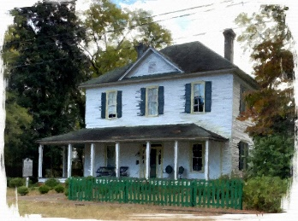  92. William Apollos  James House  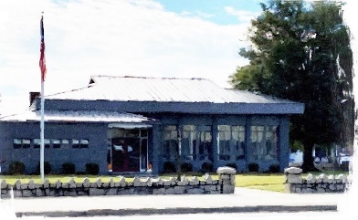  96. Woodward Library of Archives & Research |  | 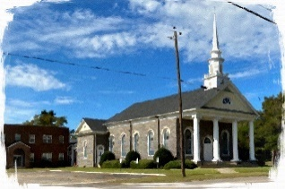  33. Bishopville Baptist Church  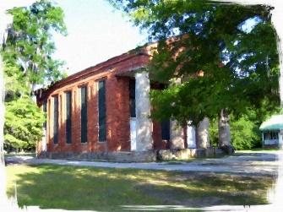  37. Black River Salem Presbyterian Church  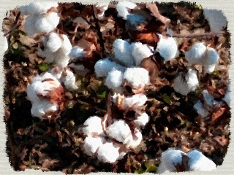  41. Cotton  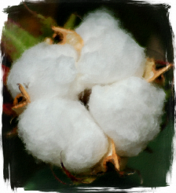  45. Cotton  Close up  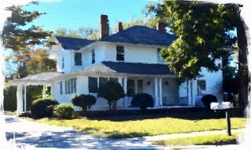  49. Deschamps House  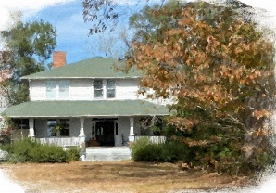  53. George McCutchen II, House  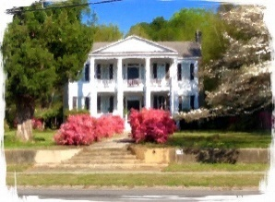  57. James Carnes House  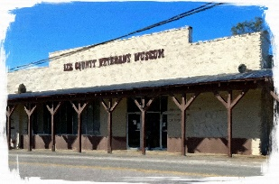  61. Lee County Veterans Museum, Facade  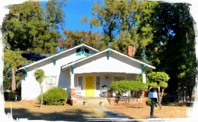  65. Mason Woods House  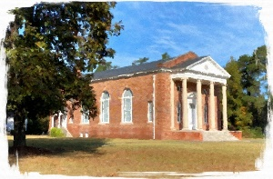  69. Mt. Zion Presbyterian Church  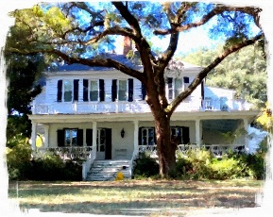  73. Plain Hill  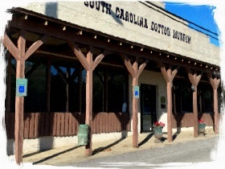  77. South Carolina Cotton Museum, Facade  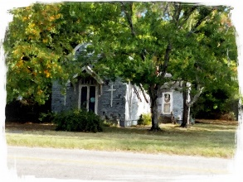  81. St. John’s Catholic Church  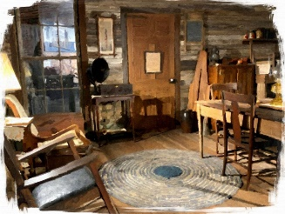  85. Tenant House, Sitting  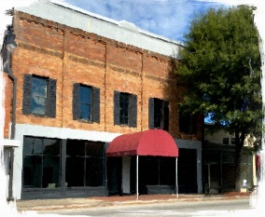  89. The Opera House  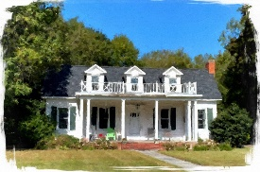  93. William Baskin House  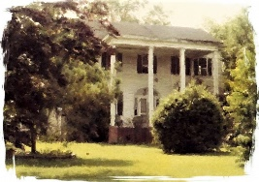  97. Hilltop |  | 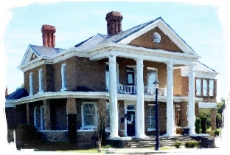  34. Bishopville City Hall  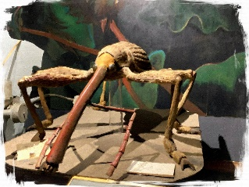  38. Boll Weevil Exhibit- SC Cotton Museum  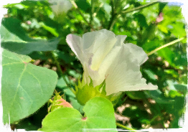  42. Cotton Bloom White  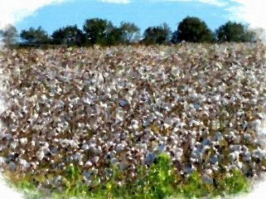  46. Cotton Field  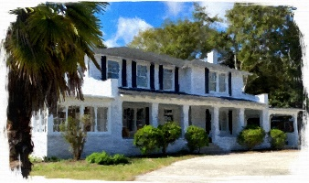  50. E. G. Deschamps House  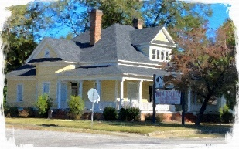  54. Gordon Parrott House  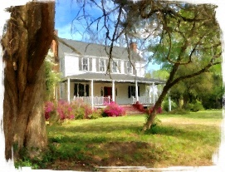  58. Jared Law House, Elliott  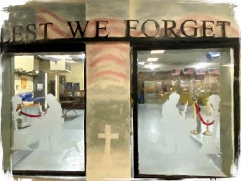  62. Lee County Veterans Museum, Entrance  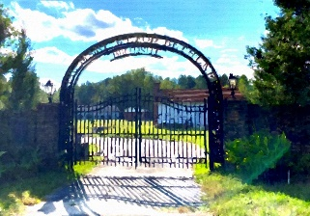  66. Mary McLeod Bethune Park  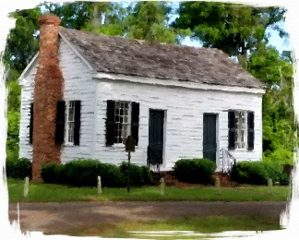  70. Mt. Zion  Session House  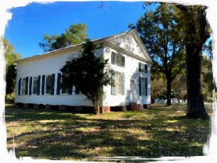  74. Rembert Church  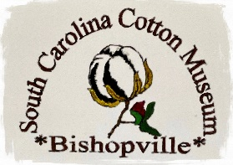  78. South Carolina Cotton Museum, Logo  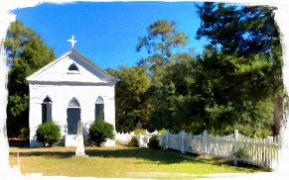  82. St. Philip’s Episcopal Church  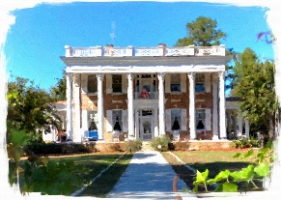  86. The Manor  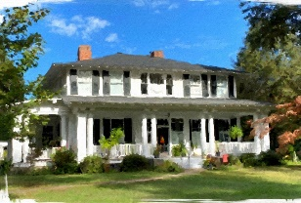  90. Thomas English McCutchen House  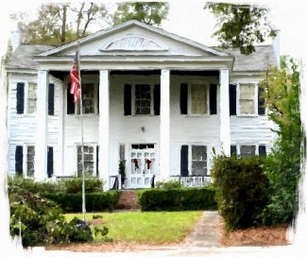  94. William Rogers House

